UML(only basic project require, without bonus part):

mainwindow:

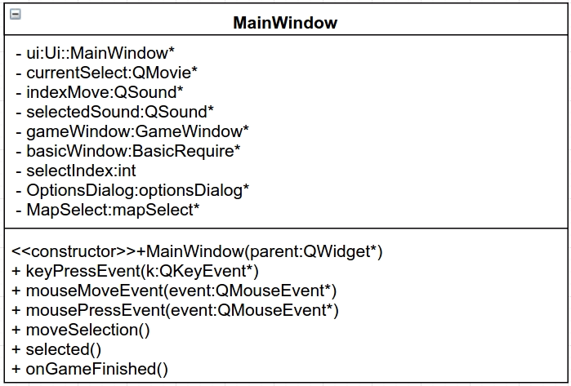

basicrequire:

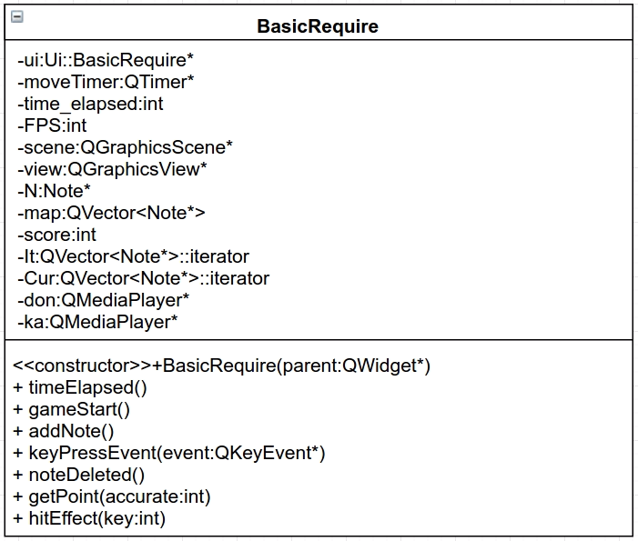

note:

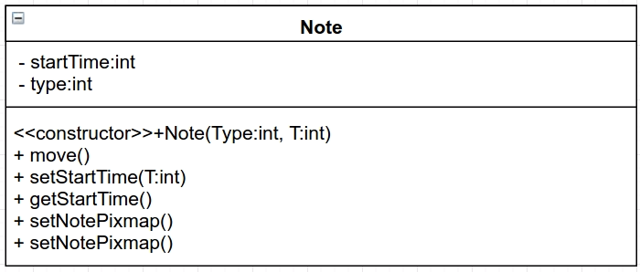

Screenshots:

mainwindow:

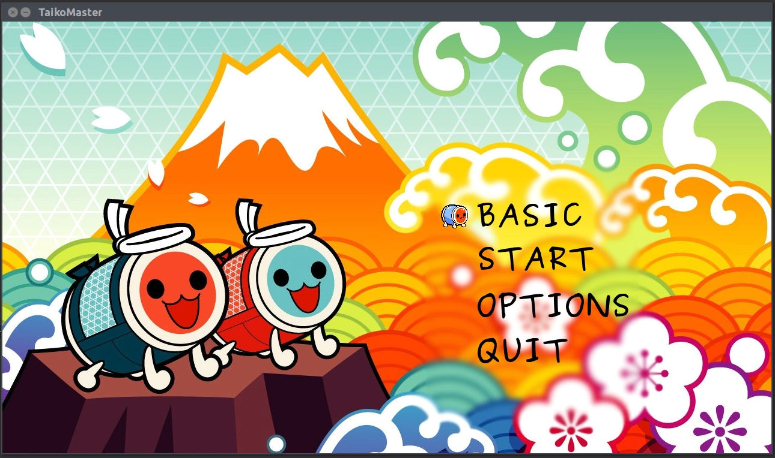

basic require:

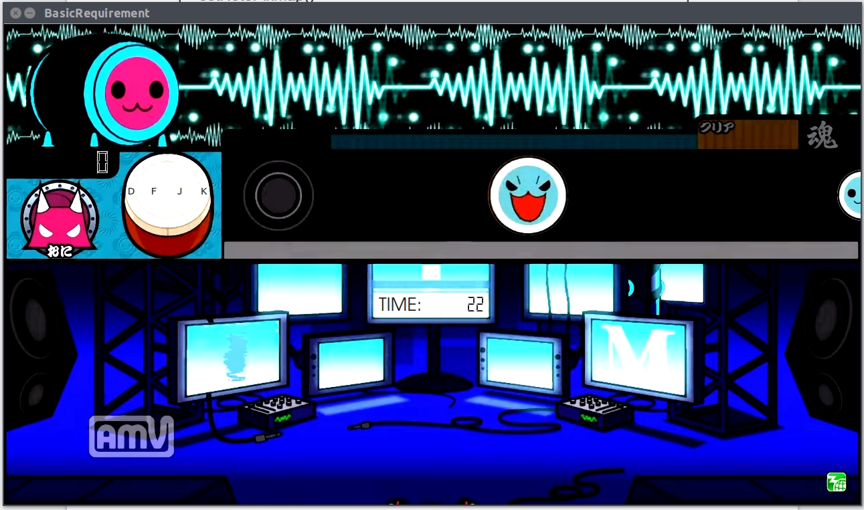

game settings(only work for bonus gameplay):

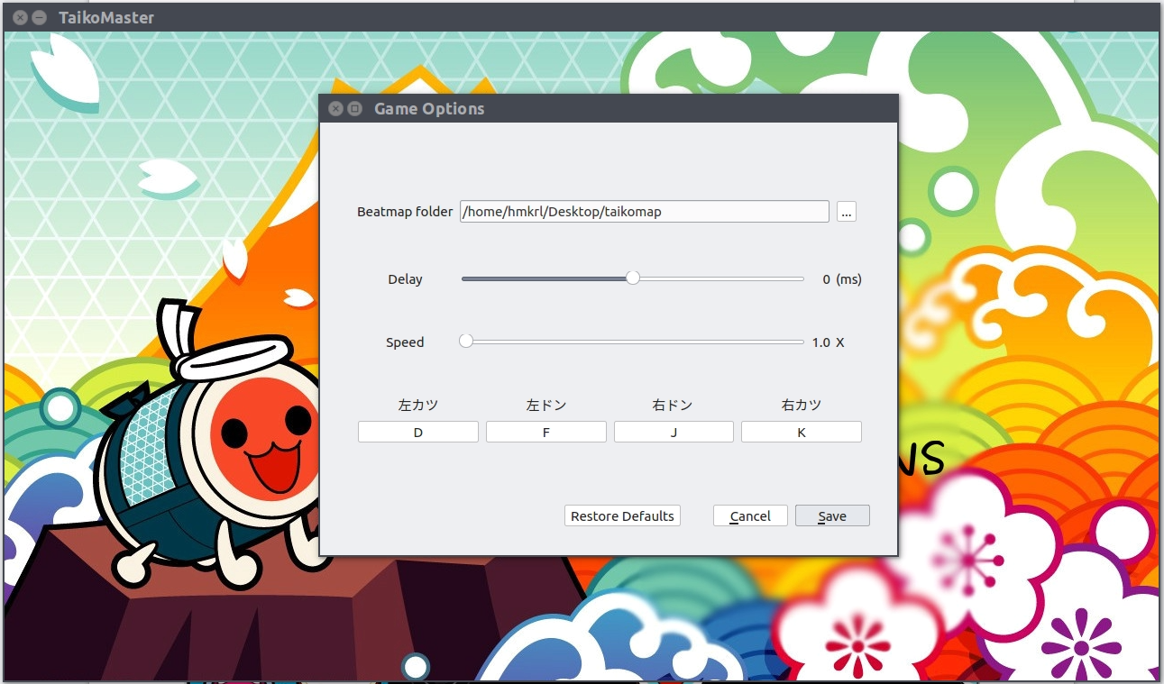

result screen

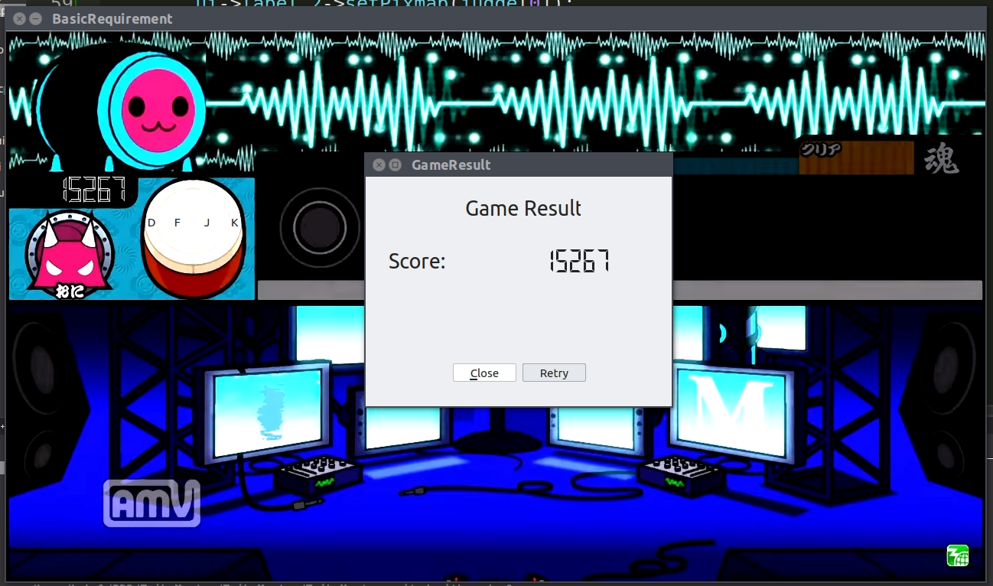

How to play:

When program launched, there will be four options, you can move the selection index using both keyboard(up and down key) or mouse(just move the pointer onto the text) and choose the option by pressing enter or left-click the mouse.

For basic project requirement, just choose “BASIC” mode, use “D” or “K” key to hit blue notes, “F” or “J” for red notes.

For bonus, choose “START”, then select the beatmap you want to play(beatmap not included in the program, I will show it in demo day).

In “OPTIONS” menu, you can adjust game options such as beatmap folder, note acceleration, beatmap delay and which key to hit the note, these settings will only applied onto bonus gameplay.These options will keep even if you restart the program, the settings will saved in the file ”TaikoConfig.ini”.

Program architecture:

basicrequire class for basic gameplay window.

basicresult class for result winwdow.

gamewindow for bonus gameplay.

keyconf window for receving settings key.

mainwindow class for main menu.

mapselect for beatmap selection.

note class for drums.

optionsdialog for game settings.